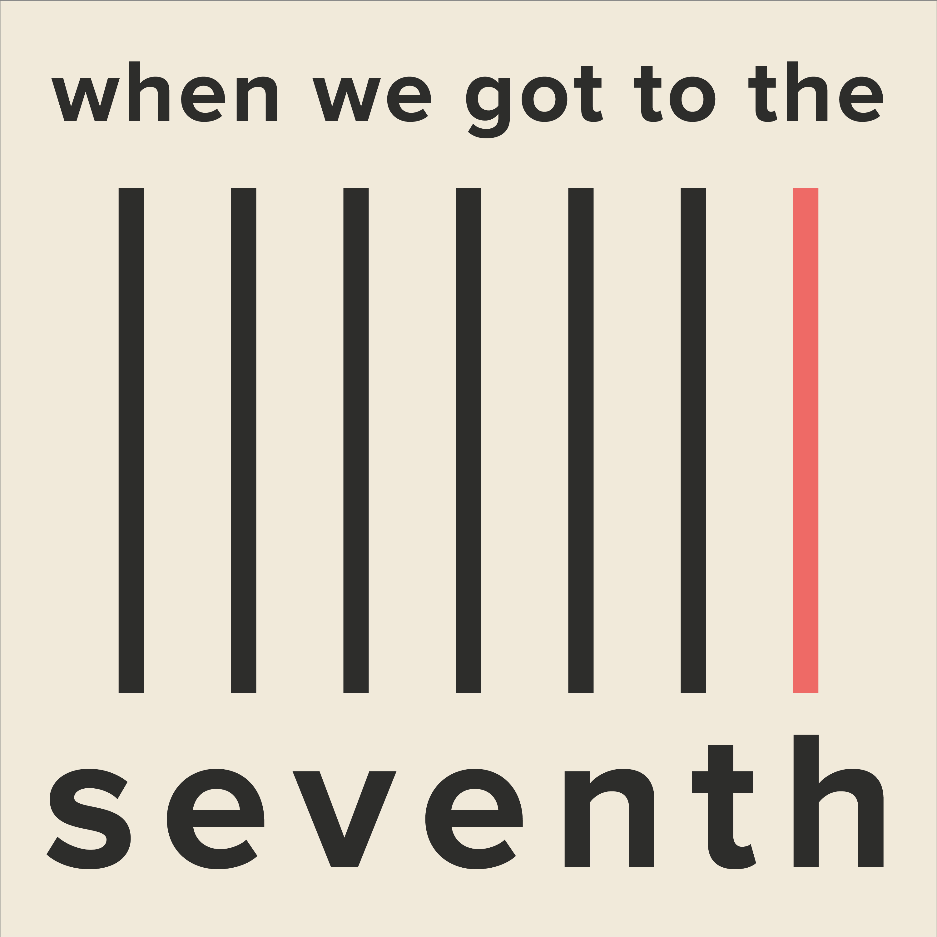

It Takes A Certain Disposition – Audio Notes Included

The mountain backdrop of most of this episode needs to evoke a sense of huge epicness – weather, loneliness, expanse, risk, danger, sky and the natural environment of Yosemite Park. Do a Google image search for ‘Yosemite Park’ and you’ll see what I mean. We need that in audio form.

Also: take a look at this amazing trailer for The Dawn Wall - https://www.youtube.com/watch?v=5Hc8tB9uhho

Music: Theme music

Opening Credits and Titles (including the additional version I sent over, of me saying the title of this ep to insert)

SFX: Log cabin atmos
SFX: An open fire
SFX: Mountainous terrain sfx: wind outside, occasional animals, rain

See the thing about mountain climbing is that it’s really dangerous. It’s not for everyone. I think it takes a certain kind of person to be a climber. At this level anyways. Professional. It takes a certain disposition.

As a child I was something of a loner. Other kids didn’t understand me.

SFX: Kids laughing, taunting in the distance, as if it’s a memory

And I didn’t understand them. I didn’t understand dolls. I used to just take ‘em apart.

SFX: Brutal sound of plastic being broken, crushed and generally maimed

To see how they were put together. And the other kids. Well, they thought that was weird.

SFX: Kids screaming and running away scared (again, as if in a memory)

Turns out the teachers thought that was weird too.

SFX: Teachers muttering, sounding concerned, as if in a separate room through a wall

And also the educational psychologists.

SFX: In the distance, somebody says in a Canadian accent “I think we need to talk about your daughter.”

SFX: Log cabin atmos back in, with fire and weather/wildlife backdrop

But hey, I turned out just fine.

I’ve always enjoyed my own company. I enjoy silence. I don’t want the pressure of social interaction. The pressure of having to think of amusing things to say. I’d much rather climb a really big rock.

It’s gotten much more complicated now. You know, now I’m something of a celebrity. At least, in the climbing fraternity. I’ve got people I have to talk to. I have a team. I have Simone my business manager who mostly I can communicate with via email.

SFX: Email arriving in Inbox

And my sponsors. Again, when Simone’s remit ends and mine apparently begins: email.

SFX: Email arriving in Inbox

Sometimes though I have to speak to the postman if he’s got a really big package. If I’ve ordered something large off of the internet.

SFX: Sound of someone knocking on a wooden door, heard from the inside
SFX: Wooden door opening a tiny bit
SFX: When the door is opened, we hear the vast expanse of parkland
SFX: As if a way off, we hear our heroine say “Just leave it on the porch and go.”
SFX: Wooden door closing

And now we’re back in the log cabin: fire, weather, animals etc

So you can understand the strength of feeling I experienced when Simone told me via email that I had to embark on arguably the most challenging and difficult climb of my life, with Maxine.

SFX: Log cabin atmos out
Music: To signify Maxine: cool, desirable – maybe some sort of ‘fashiony’ music?

Maxine is everything I am not. Oh sure, she’s a big noise in the climbing world. She’s got, like, half a million Instagram followers and like, a gazillion sponsorship deals because she’s into hair products and smartphones and has her own sportswear brand and is known as The Vegan Climber. I mean, sure. Maxine is great. She’s got a big fanbase. She’s been retweeted by at least one Kardashian.

Which is why she had to do this climb with me. Apparently. That’s what they said. They said no Maxine, no money.

Maxine’s music out

We’re back in the log cabin

This climb is a big deal, they said.

SFX: Email arriving in Inbox

It’s gonna have a lot of sponsorship and publicity potential, they said.

SFX: Email arriving in Inbox

Can’t you at least consider getting an eyebrow wax and some concealer, they said.

SFX: Email arriving in Inbox

Because there’ll be photographs. Inevitably Maxine will photograph you.

She won’t, I thought. But I didn’t say it.

Log cabin atmos out
Maxine’s music back in

Maxine is, habitually, into free soloing. This means she climbs without ropes or anchors. It’s just her and her hands and feet, clinging to the rock like a maniac.

Maxine’s music out
We’re back in the cabin again

She’s a showboater. I think free soloing is selfish and reckless and frankly just showing off.

She said in one of her Instagram posts that she had to climb the wall to stop her going up the wall. I think she thought it was going to turn into a meme. She said she was getting over a bad break-up and was going to use the mountain to heal her soul.

What a load of baloney. Climbing a mountain is no joke and it’s no place for - excuse my French - a masturbatory narcissistic pity-party.

Some kind of sinister vibe in – maybe a drone. Something to signify danger, and the seriousness of this climb.

Five people have died in climbing accidents on El Capitan since 2013. I keep a database of all 1,839 deaths that have occurred in the park. It’s not morbid. It’s research.

Sinister vibe out
Log cabin atmos out

Music in to signify El Cap – something very epic but not classical – ambient and awesome

All my life I’ve wanted to climb El Cap. It’s the biggie. It’s a mountain that inspires awe and wonder. It is a mountain of epic grandeur.

El Cap music out
Log cabin atmos in

And I wanted to do it alone. On my own. Just me and the rock. And of course my ropes. And my anchors, obviously. And my food and water. And baby wipes. And the other necessary equipment but essentially I wanted to do it on my own.

Log cabin atmos out
El Cap music in

All my life I’ve wanted to be the first woman to ascend The Grand Slab of El Cap - which, incidentally is a climb that involves some of the most difficult pitches on the whole planet because there are lots of blanks where basically the wall is very flat and there are no clear rock features to grab onto so you’ve got to be really really really really good. Just to even think about doing it.

And I’d wanted to do it alone. As the first woman. In the world.

El Cap music out
Some kind of EQ that sounds cold on the next line

But no. I had to do it with Maxine.

SFX: Email arriving in Inbox
Log cabin atmos in

Simone said I should follow her on social media to ‘get her vibe’ and exchange messages before we physically meet. Of course I realised I’d have to meet her before the climb. I knew that.

To cut to the chase, we met. We were cheese and chalk. She’s got big frizzy hair that I know will become an issue in the Rostrum.

Log cabin atmos out
SFX: Huge wind, massive outdoorsy atmos, the elements, human vulnerability

That’s the tent we’ll rig against the mountain thousands of feet up the rock, that is the basecamp of the ascent. Just a flimsy looking thing strapped to the rock face to protect us from the elements.

Massive outdoors sfx out

Log cabin atmos in

And in that environment it’s irresponsible to have that much hair.

I told her that I’d only be prepared to climb with her if she wore a hood or a hat or a scarf. She thought that was funny. The big idiot.

SFX: Email arriving in Inbox

The team kept telling me that teamwork was crucial on a climb like this. That it was essential that I had to try to get along with Maxine. That I should do everything I could to build up trust. Yeah, right.

Anyways. The project was beset by difficulty at the start. The weather was wrong. The wind was too high. Maxine had a sore throat. Maxine had a sore ankle. Maxine had her period. But on the seventh day, very early in the morning, I said

Log cabin atmos out

SFX: EQ to make her sound huge on this next line only

enough was enough and that I wanted to start.

EQ: As if she’s outside in a forest or something, leaves and twigs underfoot, wind through trees

It was the first thing I’d said for a while so everybody stopped and listened. And I actually think I may have said it very loudly. So loudly that I inadvertently alarmed a bighorn sheep, which meant it had specific impact.

SFX: Baaaa
SFX: Sheep running away quickly

We’d obviously done a lot of preparation and we knew all the pitches of The Grand Slab.

Same sinister drone used earlier back in

There’s another route to the summit known as Fool’s Vein that’s taken the lives of three climbers. It’s impossible to climb but of course Maxine said she’d like to give it a try.

Sinister drone out
Same ‘cold’ EQ used earlier on the following line only

I put my foot down. NO. I said. NO. And that was that. We were going up the Grand Slab.

Massive outdoors SFX in

When you climb a mountain it’s like grabbing razor blades embedded into the wall. Your hands find the dots of cracks, crimps, dishes, hollows, noses and if you’re lucky, ledges. it hurts. It makes your fingers bleed. It’s cold and scary and sometimes it’s wet and your eyes hurt with the sunlight but nothing good in the world ever happened because people were happy and cosy.

I could hear Maxine some feet away giving a running commentary as she climbed.

SFX: Climbing sounds – hands and feet on rock.

I think she was recording herself. It was pathetic. “I’m moving gracefully, balletically even: drive up off the left foot into the thumb press, roll two fingers over the thumb, switch feet, left foot out to a sloping foothold, switch thumbs, launch into the karate kick …”

Massive outdoors backdrop out
‘Cold’ EQ in on the following line only

Listening to her stupid voice made me want to punch her in the throat.

Massive outdoors backdrop in, with animal sfx dotted throughout to illustrate her words

On the first day we climbed and climbed. I felt strong and the conditions were perfect. The rock was beautiful. Glass smooth in places. Cheeky and unpredictable in others. You can hear the animals in the park. There are bears. Coyotes. Vultures. Sometimes a bird will fly at you as the sun comes up over the outcrop and you’ll think it’s going to peck out your eyes.

SFX: Bird flapping towards us, coming close, then flying away (maybe a pigeon sound effect might work?)

That kind of thing makes me laugh a lot when I’m clinging to a rock.

SFX: Soft, gentle rain in under a little of the following

If you’re lucky, when it’s raining, you’ll see a rainbow arcing off the side of the mountain.

SFX: A shimmery, ‘rainbow’ sound

It’s the most beautiful place on earth.

Massive outdoor atmos out
‘Cold’ EQ in on the following line only

And I had to share it with Maxine. I was not what you’d call a happy bunny.

SFX: As if inside a tent, with a huge landscape and weather outside. We hear the wind whistling – we’re very high up

Anyway, we got to the site where we were going to rig up the Rostrum and when we were inside the tent I had to talk to her. I mean, to ignore her in that situation might have come across as rude.

She asked me if I kept a climbing journal.

No, I said.

She said she liked to keep a record of how she felt on every climb. If she saw a beautiful juniper tree she liked to write a memory of it. She’d write things like “I miss my mom.” “I miss my dog.”

She said she was into meditation. After dinner - which was a wholesome tin of chickpeas and pasta cooked on the tiny stove in the tent - Maxine asked me to meditate with her. She started chanting.

Sound of chanting for a couple of seconds – a memory, not the real thing

It was unbearable.

I said I was tired and wanted to sleep. Then she started crying, saying she missed Brad - he’s the guy who dumped her - and saying she wanted to have a baby. Too bad you’re single and ageing, I said. Then she cried some more.

Sound of someone whimpering a little

Eventually she fell asleep but that was no respite because she snored. And as I’ve already said, she was a vegan.

Somebody quietly breaking wind

SFX: A ‘morning’ sound – as if the sun’s come up and everything is fresh and waking up

The next morning I was exhausted but I was eager to make progress. My wrist hurts, said Maxine. I don’t think I can climb today. So after all her brouhaha I had to sit it out with her.

SFX: Massive outdoors backdrop, heard inside a tent. It should sound claustrophobic.
SFX: Rain on canvas, heard from the inside

It was windy and it rained. I suggested we play I Spy which I thought was pretty generous because I’m not a gamey sort of person but she declined. She said once we’d guessed ‘tent’ and ‘mountain’ we might run out of material. I thought her tone was rather sarcastic.

She tweeted a lot.

SFX: Tweet noises and text alerts etc

She’d brought a keypad with her so she could ‘connect with the world.’ Which means she wanted to make money off of her posts. It was sickening. She posted pictures. She got excited when people interacted with her online. She giggled.

Sound of a woman giggling in the background

Giggled. On a mountain. It was so inappropriate. I hated her.

That night she didn’t meditate. Worse. She sang. English folk songs.

Sound of someone singing bad folk songs

Then she ate potato chips.

Crisp bag rustling. Somebody loudly chewing crisps

Loudly.

She’d done the shopping list and consequently the peanut butter I had specifically requested had not been included in the kit. Maxine made damn sure she got her pesto, her red bell peppers and her lip balm. But as for my peanut butter, that was a different story.

She said she wanted to make toilet. On a Rostrum, you have to do it off the edge. It takes practice.

With the tent open, we can hear the outdoors louder and clearer

She sat on the edge of the Rostrum to do her business and then she asked me what my happiest memory was. She said she wanted to get to know me. If there’s anything I detest it’s that.

And then it all happened so fast.

SFX: A skuffle, a struggle

She must have lost her footing or her balance and before I knew it, she wasn’t there any more and I was sort of stretched out across the Rostrum towards the opening. I heard a sort of gasp as though she was surprised by something,

Small gasp, then the whoosh of someone falling thousands of feet towards certain death

Slightly louder weather/outdoors atmos

and then there was just wind and weather in the space where Maxine had been.

All outdoors SFX out
‘Cold’ EQ in the following line only

I’ll admit it was a shock.

Log cabin atmos in

One second she was there and the next she wasn’t. I think she’d fallen, which is obviously a bad thing to have happened.

Log cabin atmos out
We’re back in the tent, thousands of miles up the mountain, surrounded by rock, the landscape and the weather

I faced a choice. I figured it was in everyone’s best interests if I just got on with the job I was there to do and make it to the summit, even if it meant doing it alone.

A faraway – very subtle – echo of Maxine’s music in

A lot of sponsorship was riding on this climb. People had expectations.

Maxine’s music out

I had a reputation to maintain.

So I made my preparations and gathered by equipment to begin my ascent.

SFX: V subtle minimalist music to suggest the sense of beauty, glory, epic grandeur and the awesomeness of nature. Perhaps a variation on the El Cap theme from earlier??

It was a beautiful morning. Dark, still. Very quiet. The stars were beginning to fade and the sky was turning colour, gently, every second.

SFX: Climbing sfx – someone’s hands and feet on rock

My body moved against the rock, my ropes knotting to the anchors with efficiency and precision. I took no risks. Heck, every second you’re climbing, you’re dicing with death, let’s face it.

My hands moved on the mountainside as though they were acquainting themselves with an old friend. The mountain held me. Propelled me onwards, upwards. And before the sun was up, I was near the summit.

SFX: “Exhilaration” - maybe a choir, harps?? But subtle though, and far-off

The exhilaration I experienced was off the charts. I felt a heady mixture of pride, delight and what I think was pure joy as I completed my task. I was there. I’d done it. I’d climbed the Grand Slab of El Cap. The first woman to do it in the whole world.

All other atmos and music out
‘Cold’ EQ back in on this final line

It was a helluva deal. And man, what an achievement. It’s just a shame Maxine wasn’t there to see me do it.

SFX: Massive outdoors atmos in, swells, music signifying El Cap back in and swells
Reverse crash out.
Silence

Theme music in
End credits, to include the note I’ve already sent over

(c) Emma Clarke Ltd. All rights reserved.

